**(Q) What are the benefits of using CSS?**

**A.** 1. Faster page speed

2. Better user Experience

3. Quicker Development Time

4. Easy formatting changes

5. Compatibility Across Device

6. Time – saving

7. Easier to maintain

8. Consistent design

9. Positioning of design elements

**(Q) What are the disadvantages of CSS?**

**A.**1. Confusion due to many CSS versions

2. Cross – browser issues

3. Limited security

4. Extra work for developers

**(Q) Name a few CSS style components.**

**A. selector:** class name, id name or element name that is target

**Attribute:** style for example border, colour, background, position etc.

**Value of Property:** value that will be assigned to attribute.

**(Q) What is the difference between CSS2 and CSS3?**

**A.**

|  |  |
| --- | --- |
| **CSS 2** | **CSS 3** |
| CSS splits up different section of the code into modules | Both CSS and HTML were put into a single file, there was no concept of modules before. |
| There are new ways you can write CSS rules with a bunch of CSS selectors | There were no new ways of writing the CSS rules. |
| There is no backword compatibility | There is backward compatibility maintained with CSS 3 |
| With CSS2 only web safe fonts can be used | With CSS 3 special fonts can be used such as those in Google fonts and Typecast |
| With CSS2 the concept of simple selectors Were present | With CSS3, there is provision for automatically assigning rounded borders to objects |
| CSS2 Doesn’t support the Border-Box property | CSS3 support the Border-Box property |

**(Q) What do you understand by CSS opacity?**

**A.**  The opacity CSS property sets the opacity of an element. Opacity is the degree to which content behind and element is hidden, and is the opposite of transparency.

Opacity value: 0 to 1

**Input:**

<!DOCTYPE html>

<html lang="en">

<head>

    <meta charset="UTF-8">

    <meta name="viewport" content="width=device-width, initial-scale=1.0">

    <title>Document</title>

    <style>

        div{

            background-color: black;

            color: white;

        }

        .one{

            opacity: 0.5;

        }

    </style>

</head>

<body>

    <div class="one">WELCOME</div>

    <div class="two">GOOD BYE</div>

</body>

</html>

**Output:**



**(Q) How can the background color of an element be changed?**

**A.** The background-color property in CSS is used to set the background color of an element. It applies solid colors as the element’s background.

**Input:**

<!DOCTYPE html>

<html lang="en">

<head>

    <meta charset="UTF-8">

    <meta name="viewport" content="width=device-width, initial-scale=1.0">

    <title>Document</title>

    <style>

        div{

            height: 100px;

            border: 2px solid black;

            font-size: xx-large;

            text-align: center;

        }

        .one{

            background-color:aqua ;

        }

        .two{

            background-color: yellow;

        }

        .three{

            background-color: pink;

        }

    </style>

</head>

<body>

    <div class="one">background color:- aqua</div>

    <div class="two">background color:- yellow</div>

    <div class="three">background color:- pink</div>

</body>

</html>

**Output:**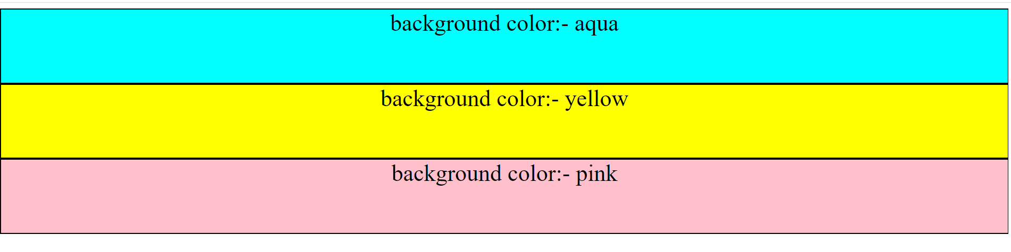

**(Q) How can image repetition of the backup be controlled?**

**A.** The background-repeat property in CSS is used to repeat the background image both horizontally and vertically. It also decides whether the background image will be repeated or not.

**Example:**

Background-repeat: repeat;

Background-repeat: repeat-x;

Background-repeat: repeat-y;

Background-repeat: no-repeat;

Background-repeat: inherit;

Background-repeat: initial;

**Input:**

<!DOCTYPE html>

<html lang="en">

<head>

    <meta charset="UTF-8">

    <meta name="viewport" content="width=device-width, initial-scale=1.0">

    <title>Document</title>

    <style>

        body{

            height: 600px;

            width: 600px;

            background-image: url("https://th.bing.com/th?id=OIP.Vt3kGu4X6WQlmH91GpJpzgHaFH&w=300&h=207&c=8&rs=1&qlt=90&o=6&dpr=1.3&pid=3.1&rm=2");

            background-repeat: repeat-x;

        }

        img{

            height: 150px;

            width: 150px;

        }

    </style>

</head>

<body>

</body>

</html>

**Output:**

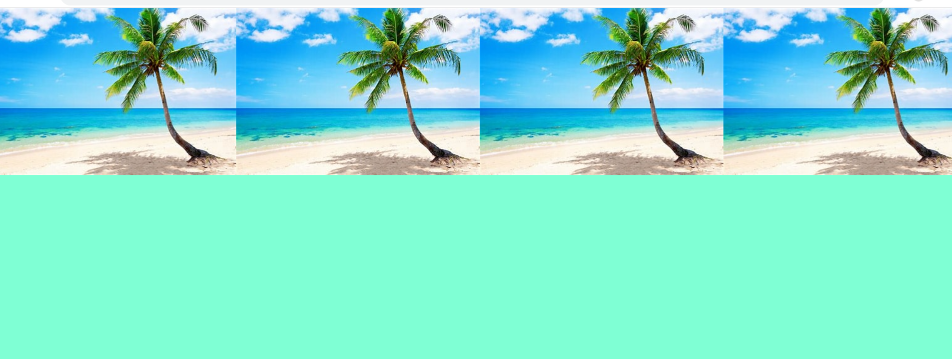

**(Q) What is the use of the background-position property?**

**A.** The background-position property sets the starting position of a background image.

**Example:**

Background-position: left-top; left-center; left-bottom;

Background-position: right-top; right-center; right-bottom;

Background-position: center-top;

Background-position: 10% 30%;

Background-position:50px 100px;

**Input:**

<!DOCTYPE html>

<html lang="en">

<head>

    <meta charset="UTF-8">

    <meta name="viewport" content="width=device-width, initial-scale=1.0">

    <title>Document</title>

    <style>

        div{

            height: 600px;

            width: 600px;

            background-color: aquamarine;

            background-image: url("https://th.bing.com/th?id=OIP.Vt3kGu4X6WQlmH91GpJpzgHaFH&w=300&h=207&c=8&rs=1&qlt=90&o=6&dpr=1.3&pid=3.1&rm=2");

            background-repeat: no-repeat;

            background-position: center;

        }

    </style>

</head>

<body>

    <div></div>

</body>

</html>

**Output:**



**(Q) Which property controls the image scroll in the background?**

**A.** The background-attachment property sets whether a background image scrolls with the rest of the page, or is fixed.

**Example:**

**Background attachment :**

**Scroll:** background-image will scroll with the page.

**Fixed:** background-image will not scroll with the page.

**Local:** background-image will scroll with the element’s contents.

**Initial:** its default value.

**Inherit:** this property from its parent value.

**Input:**

<!DOCTYPE html>

<html lang="en">

<head>

    <meta charset="UTF-8">

    <meta name="viewport" content="width=device-width, initial-scale=1.0">

    <title>Document</title>

    <style>

        div{

            height: 600px;

            background-color: aquamarine;

            background-image: url("https://th.bing.com/th?id=OIP.Vt3kGu4X6WQlmH91GpJpzgHaFH&w=300&h=207&c=8&rs=1&qlt=90&o=6&dpr=1.3&pid=3.1&rm=2");

            background-repeat: no-repeat;

            background-position: center;

            background-attachment: fixed;

        }

    </style>

</head>

<body>

    <div></div>

</body>

</html>

**Output:**

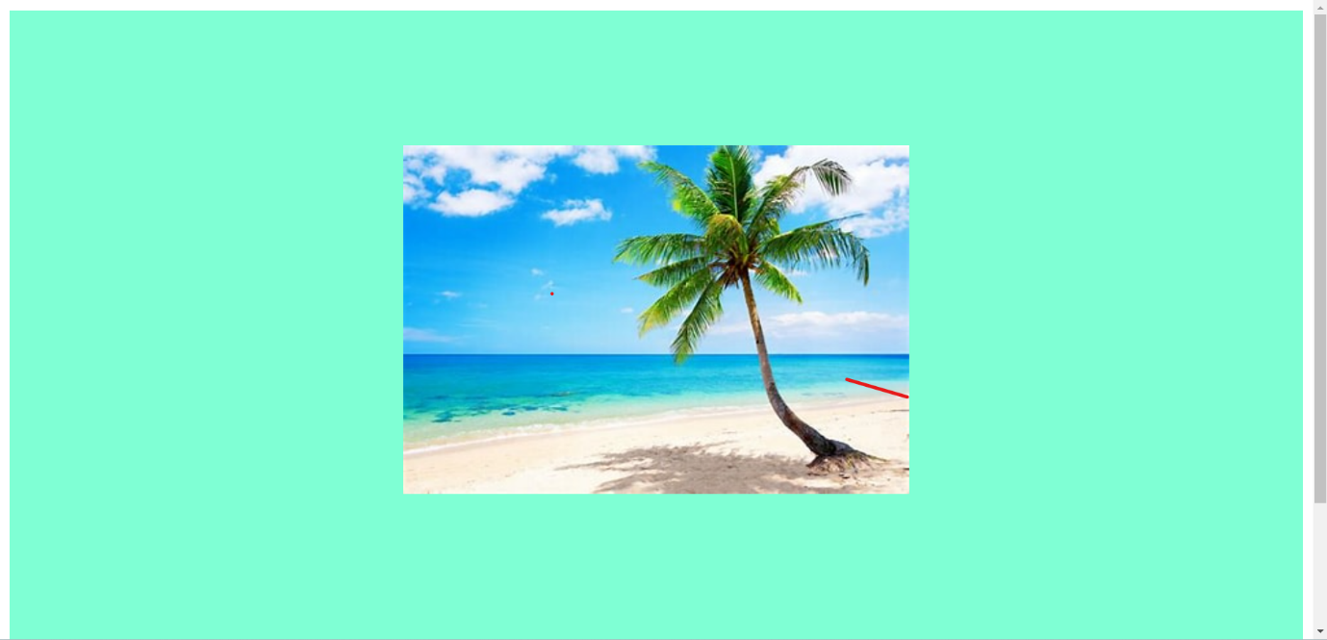

**(Q) Why should background and color be used as separate properties?**

**A.** The background property is a complex property in CSS, and if it is combined with color, the complexity will further increase.

**Example:**

Color: orange;

Background-color: green;

**Input:**

<!DOCTYPE html>

<html lang="en">

<head>

    <meta charset="UTF-8">

    <meta name="viewport" content="width=device-width, initial-scale=1.0">

    <title>Document</title>

    <style>

        p{

            height: 100px;

            width: 100px;

            color: crimson;

            background-color: aquamarine;

            text-align: center;

        }

    </style>

</head>

<body>

    <div>

        <p>WELCOME</p>

    </div>

</body>

</html>

**Output:**

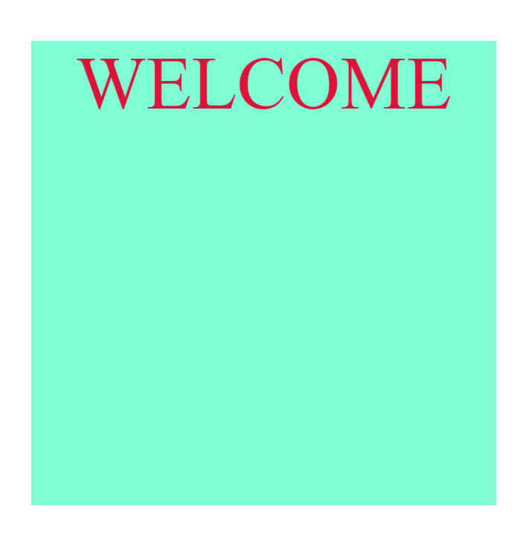

**(Q) How to center block elements using CSS1?**

**A.** To centrally align the block elements, we can simply make use of the <center> tag.

**Input:**

<!DOCTYPE html>

<html lang="en">

<head>

    <meta charset="UTF-8">

    <meta name="viewport" content="width=device-width, initial-scale=1.0">

    <title>Document</title>

    <style>

        div{

            height: 100px;

            width: 300px;

            background-color: aquamarine;

        }

    </style>

</head>

<body>

    <center>

        <div>

         <h1>welcome</h1>

        </div>

    </center>

</body>

</html>

**Output:**

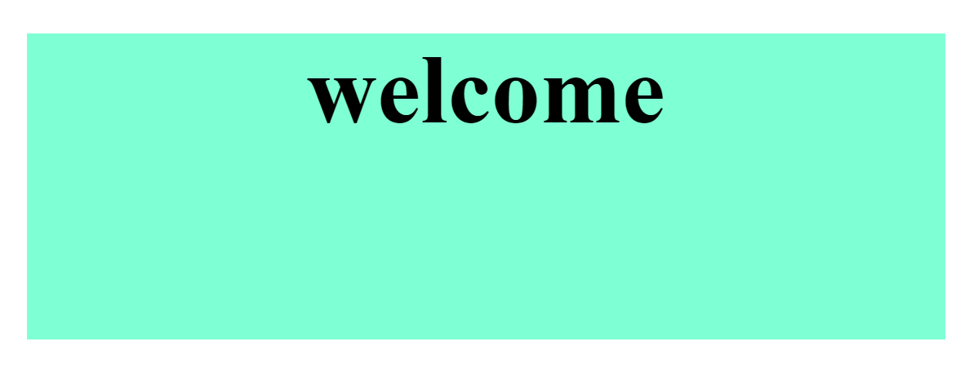

**(Q) What are the ways to integrate CSS as a web page?A. CSS can be added to HTML documents in 3 ways:**

**Inline –** by using the style attribute inside HTML elements.

**Internal –** by using a <style> element in the <head> section.

**External –** by using a <link> element to link to an external CSS

File.

**Input:** forinline and internal CSS

<!DOCTYPE html>

<html lang="en">

<head>

    <meta charset="UTF-8">

    <meta name="viewport" content="width=device-width, initial-scale=1.0">

    <title>Document</title>

    <style>

        .one{

            height: 200px;

            width: 200px;

            background-color: aquamarine;

        }

    </style>

</head>

<body>

    <div class="one">

        <p style="color: crimson;">WELCOME</p>

    </div>

</body>

</html>

**Input:** for external CSS

HTML code:

<!DOCTYPE html>

<html lang="en">

<head>

    <meta charset="UTF-8">

    <meta name="viewport" content="width=device-width, initial-scale=1.0">

    <title>Document</title>

    <link rel="stylesheet" href="external css.css">

</head>

<body>

    <div class="one">

        <p>WELCOME</p>

    </div>

</body>

</html>

CSS code:

.one{

  height: 200px;

  width: 200px;

  color: crimson;

  background-color: aquamarine;

}

**Output:**

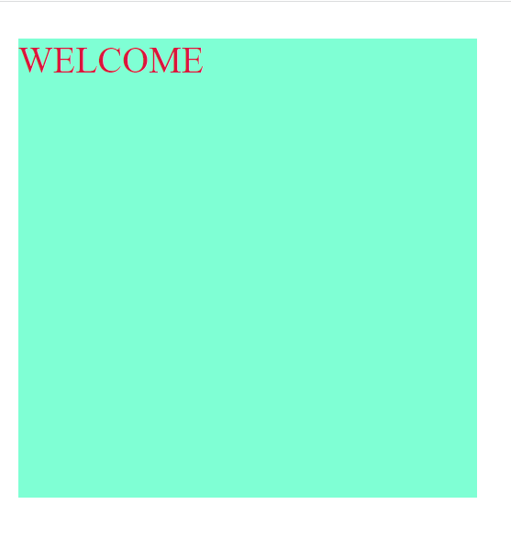

**(Q) What is embedded style sheets?**

**A.** Embedded style sheets is exactly the same as other CSS code,aprt from the fact that it is now wrapped within the <style></style> tags.

**Input:**

<!DOCTYPE html>

<html lang="en">

<head>

    <meta charset="UTF-8">

    <meta name="viewport" content="width=device-width, initial-scale=1.0">

    <title>Document</title>

    <style>

        .one{

             height: 200px;

             width: 200px;

             color: rgb(253, 3, 53);

             background-color: rgb(190, 242, 225);

             text-align: center;

             font-size: xx-large;

}

    </style>

</head>

<body>

    <div class="one">

        <p><b>WELCOME</b></p>

    </div>

</body>

</html>

**Output:**



**(Q) What are the external style sheets?**

**A.** a separate CSS file that can be accessed by creating a link within the head section of the webpage. Multiple webpages can use the same link to access the styleshit.

**Input:** HTML code

<!DOCTYPE html>

<html lang="en">

<head>

    <meta charset="UTF-8">

    <meta name="viewport" content="width=device-width, initial-scale=1.0">

    <title>Document</title>

    <link rel="stylesheet" href="external css.css">

</head>

<body>

    <div class="one">

        <p>HELLO</p>

    </div>

</body>

</html>

**Input:** for external CSS

.one{

    height: 200px;

    width: 200px;

    color: rgb(253, 3, 53);

    background-color: rgb(190, 242, 225);

    text-align: center;

    font-size: xx-large;

    border: 2px solid black;

}

**Output:**

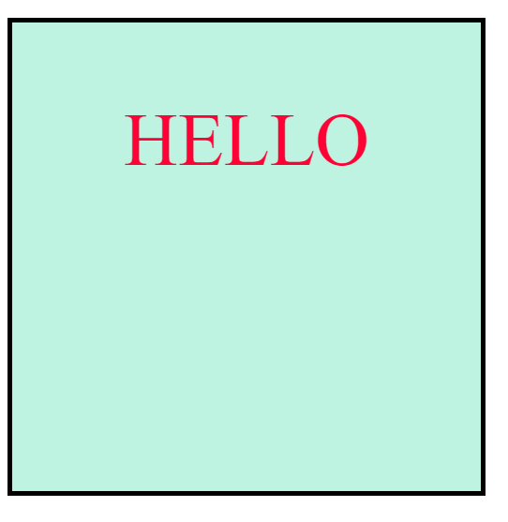

**(Q) What are the advantages and disadvantages of using external style sheets?**

**A.**

**Advantages :**

● one change to the style sheet will changes all linked pages.

● you can create classes of styles that can then be used on

Many different HTML elements.

● consistent look and feel across multiple web pages.

● improved load times.

**Disadvantages :**

● your pages may not be rendered correctly until the external

CSS is loaded.

● Uploading or linking to multiple CSS file can increase your

Site’s download time.

**(Q) What is the meaning of the CSS selector?**

**A.** CSS selectors are used to “find” ( or select) the HTML elements you want to style.

**◙ WE can divided CSS selectors into five categories.**

**(1) Simple selector:** select elements based on name, id, class.

**Example:** div , .one , #two

**(2) Combinator selectors:** select elements based on a specific

relationship between them**.**

**Example:** general sibling selector ( ~ )

Adjacent sibling selector ( + )

Child selector ( > )

Descendant selector ( space )

**(3) Pseudo-class selectors:** select elements based on a certain state

**Example:** a:link (unvisited link)

a:visited (visited link)

a:hover (mouse over link)

a:active (selected link)

**(4) Pseudo-elements selectors:** select and style a part of an element

**Example:** div::first-letter (special style to the first letter of a text)

div::before (used to insert some content before the

content of an element)

div::after (used to insert some content after the

content of an element)

div::marker (selects the markers of list items)

div::selection (matches the portion of an element that is

selected by a user)

div::first-line (special style to the first line of a text)

**(5) Attribute selectors:** select elements based on an attribute or

attribute value.

**Example:** [attribute] → [target] (selects all element with a target

Attribute)

[attribute=value] → [target=“_blank”] (selects all element

with a target “_blank”)

[attribute~=value] → [title~=“hello”] (selects all element

with a title attribute containing the

word “hello”)

[attribute|=value] → [lang|=“en”] (selects all element

with a lang attribute value starting

with “en”)

[attribute^=value] →a [href^=“https”] (selects every <a> element whose href attribute value begins with “https” element

with “en”)

[attribute$=value] →a [href$=“.pdf”] (selects every <a> element

whose href attribute value ends with “.pdf”)

**(Q) What are the media types allowed by CSS?**

**A.** there are five media types allowed by CSS.

**Example:**

**( width )**

(1) mobile screen : 320px to 480px

(2) tablet screen : 481px to 768px

(3) laptop screen : 769px to 1024px

(4) television screen : 1024px to 1200px

(5) large screen : 1200px + ( plus )

**Input:**

<!DOCTYPE html>

<html lang="en">

<head>

    <meta charset="UTF-8">

    <meta name="viewport" content="width=device-width, initial-scale=1.0">

    <title>Document</title>

    <style>

        .abc{

            height: 400px;

            background-color: white;

            display: flex;

            flex-wrap: wrap;

        }

        .one{

            height: 100px;

            width: 25%;

            background-color:aquamarine;

        }

        .two{

            height: 100px;

            width: 25%;

            background-color:rgb(74, 138, 228) ;

        }

        .three{

            height: 100px;

            width: 25%;

            background-color:rgb(198, 123, 37) ;

        }

        .four{

            height: 100px;

            width: 25%;

            background-color: cadetblue;

        }

        /* ------------------------MOBILE---------------------- */

        @media (min-width:320px)and (max-width:480px) {

            #one1{

                width: 100%;

            }

            #one2{

                width: 100%;

            }

            #one3{

                width: 100%;

            }

            #one4{

                width: 100%;

                overflow: hidden;

            }

        }

        /* ------------------------TABLET---------------------- */

        @media (min-width:481px)and (max-width:768px) {

            #one1{

                width: 50%;

            }

            #one2{

                width: 50%;

            }

            #one3{

                width: 50%;

            }

            #one4{

                width: 50%;

            }

        }

/* ------------------------TV---------------------- */

        @media (min-width:769px)and (max-width:1024px) {

            #one1{

                width: 25%;

            }

            #one2{

                width: 25%;

            }

            #one3{

                width: 25%;

            }

            #one4{

                width: 25%;

            }

        }

    </style>

</head>

<body>

    <div class="abc">

        <div class="one" id="one1">1</div>

        <div class="two" id="one2">2</div>

        <div class="three" id="one3">3</div>

        <div class="four" id="one4">4</div>

    </div>

</body>

</html>

**Output:**

**● Mobile screen**

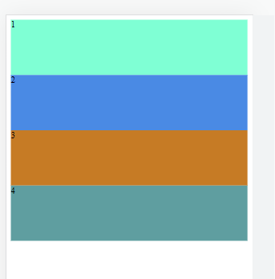

**● Tablet screen**

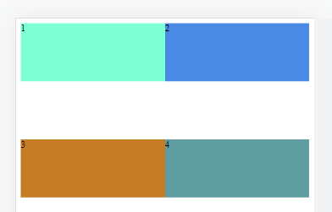

**● Laptop screen**

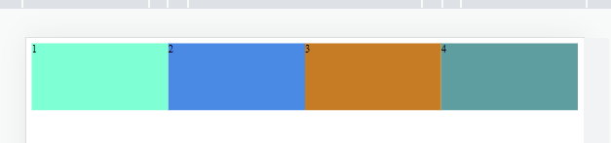

**(Q) What is the rule set?**

**A.** A CSS rule set contain one or more selectors and one or more declarations. The rule set is the main building block of a CSS sheet. Style the element with a property and value.

**Example:**

Property → width

Value → 100px

Width: 100px

**Input:**

<!DOCTYPE html>

<html lang="en">

<head>

    <meta charset="UTF-8">

    <meta name="viewport" content="width=device-width, initial-scale=1.0">

    <title>Document</title>

    <style>

        div{

            height: 100px;

            width: 100px;

            background-color: aquamarine;

            text-align: center;

        }

    </style>

</head>

<body>

    <div>HELLO</div>

</body>

</html>

**Output:**

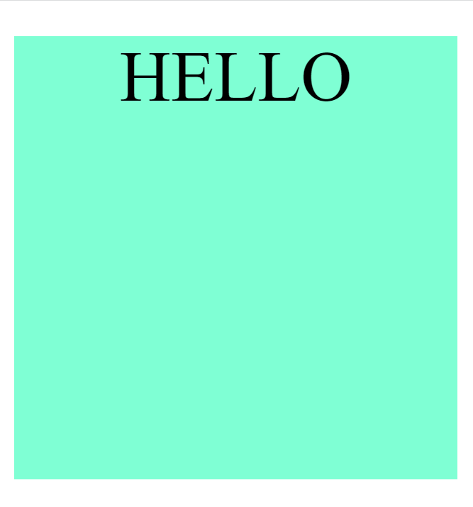

**(Q) How to maintain the CSS specifications?**

**A.** - Regular updates

- Community involvement

- Testing

- Backward compatibility

- Documentation

- Version control

- Vendor collaboration

- Openness to feedback

- Clear governance